**20.User-defined Records**

**CREATE TABLE DEPARTMENT11(DEP_ID INT PRIMARY KEY,DEP_NAME VARCHAR(20));**

**INSERT INTO DEPARTMENT11 VALUES(10,'Finance');**

**INSERT INTO DEPARTMENT11 VALUES(20,'IT');**

**INSERT INTO DEPARTMENT11 VALUES(30,'SALES');**

**INSERT INTO DEPARTMENT11 VALUES(40,'Electrical');**

**SELECT *FROM DEPARTMENT11 ORDER BY DEP_ID;**

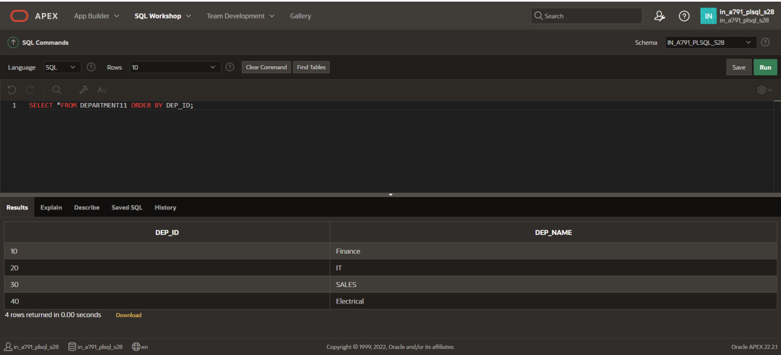

**CREATE TABLE EMPLOYEE11 (EMP_ID INT PRIMARY KEY,EMP_FIRSTNAME VARCHAR(20),EMP_LASTNAME VARCHAR(20),DEP_ID INT,FOREIGN KEY (DEP_ID) REFERENCES DEPARTMENT11 (DEP_ID));**

**INSERT INTO EMPLOYEE11 VALUES(1,'Ben','Tenizen',20);**

**INSERT INTO EMPLOYEE11 VALUES(2,'Peter','Parker',20);**

**INSERT INTO EMPLOYEE11 VALUES(3,'Henry','Cavil',10);**

**INSERT INTO EMPLOYEE11 VALUES(4,'Ram','Chandran',20);**

**INSERT INTO EMPLOYEE11 VALUES(5,'Murali','Manogar',30);**

**INSERT INTO EMPLOYEE11 VALUES(6,'Harsha','Kyle',40);**

**INSERT INTO EMPLOYEE11 VALUES(7,'Adarsh','Vishal',10);**

**SELECT *FROM EMPLOYEE11 ORDER BY EMP_ID;**

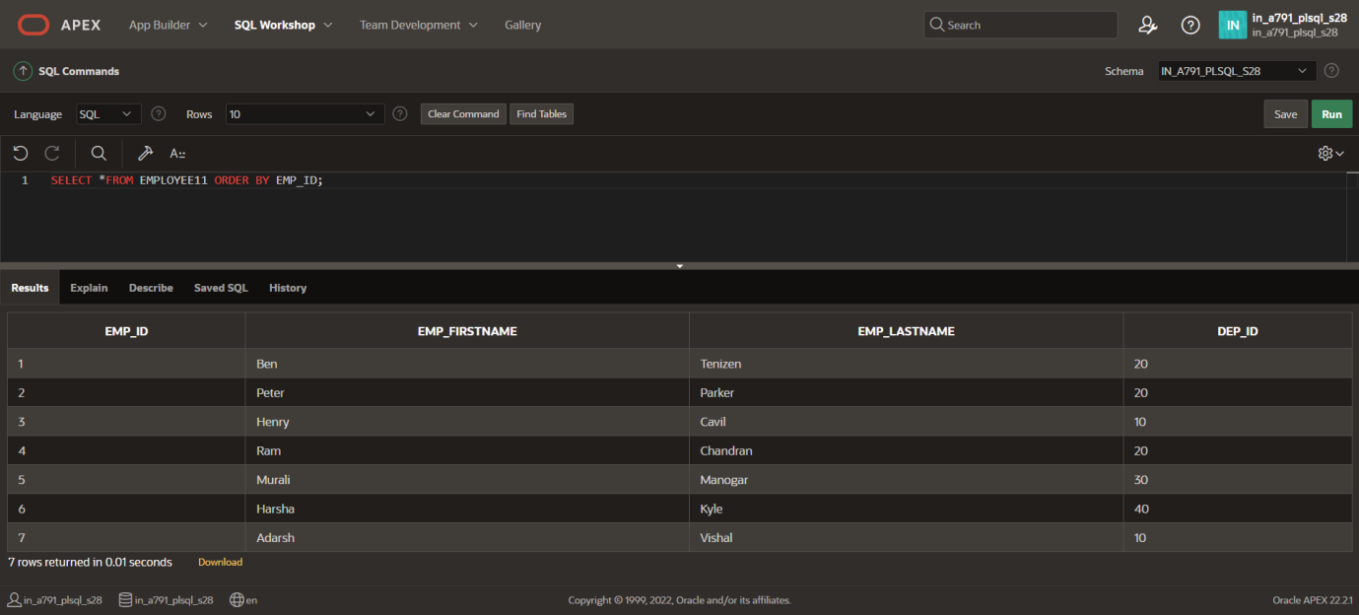

**DECLARE**

**TYPE PERSON_DEPT IS RECORD**

**(**

**EMP_FIRSTNAME EMPLOYEE11.EMP_FIRSTNAME%TYPE,**

**EMP_LASTNAME EMPLOYEE11.EMP_LASTNAME%TYPE,**

**DEP_NAME DEPARTMENT11.DEP_NAME%TYPE**

**);**

**v_person_dept_rec PERSON_DEPT;**

**BEGIN**

**SELECT e.EMP_FIRSTNAME, e.EMP_LASTNAME, d.DEP_NAME**

**INTO v_person_dept_rec**

**FROM EMPLOYEE11 e**

**JOIN DEPARTMENT11 d ON e.DEP_ID = d.DEP_ID**

**WHERE e.EMP_ID = 6;**

**DBMS_OUTPUT.PUT_LINE(v_person_dept_rec.EMP_FIRSTNAME || ' ' || v_person_dept_rec.EMP_LASTNAME || ' is in the ' || v_person_dept_rec.DEP_NAME || ' Department.');**

**END;**

**/**

